# Introduction

Recently I have joined a leading creative web solution and marketing company. This company have asked me to create a multipage website for a client. What is revealed in the assignment brief is what needs to be accomplished across the given time limit. This will contain a detailed schedule with moon boards and thorough research to create the best 5 page website possible for my client.

# Project Schedule

|  |  |
| --- | --- |
| Date | Tasks |
| 30/01/2022 | Initial meeting with client, to identify project specification. |
| 08/02/2022 | Writing project specification and identifying target audience. |
| 15/02/2022 | Designing mood bards and visual designs of web pages. |
| 22/02/2022 | Meeting with the client and potential users to discuss the visual designs |
| 1/03/2022 | Improve on the feedback received |
| 8/03/2022 | Writing justifications for the improved versions. |
| 15/03/2022 | Creating the home page using html, CSS and JavaScript. |
| 22/03/2022 | Meeting with the client to discuss the homepage |
| 28/03/2022 | Creating the about us page |
| 4/04/2022 | Creating the opening times page |
| 11/04/2022 | Creating the products page |
| 18/04/2022 | Creating the gallery page |
| 25/04/2022 | Creating the feedback page |
| 27/04/2022 | Test it for functionality, compatibility (with different devices and browsers) and usability (including user testing), using appropriate test plans, test schedules and data. You should collect results and feedback and show that you have responded to any problem or errors identified. |
| 28/04/2022 | Review and evaluation of the website |
| 29/04/2022 | Overall reflection on the project |

# Purpose of website

The purpose of this website is to create a much more understanding place for people to access yoga fitness classes. So, if a customer or user wants to see when a class is they will press on the classes section to see what class times are shown. Also, to apply for a membership there will be a form page for them to sign up on. There will be a blog daily to reveal what has happened in that day. This will make it a much more suitable and accessible place for people to give queries or ask questions.

# Target Audience

The target audience for the yoga website will be people aged from 20-60 years old because “people from 20 years old to 60 years old also practice yoga.” (academia.edu,2022). This reveals that my audience is quite a big variety with a wide age range of people can interact with it. Also, the main predominant gender for yoga is female because “While the majority of yoga practitioners are women (70%).” This connotes the importance of having a lot of women interacting with the website because it will bring in more interactions and more people understanding the importance of having a yoga website.

# Mood board

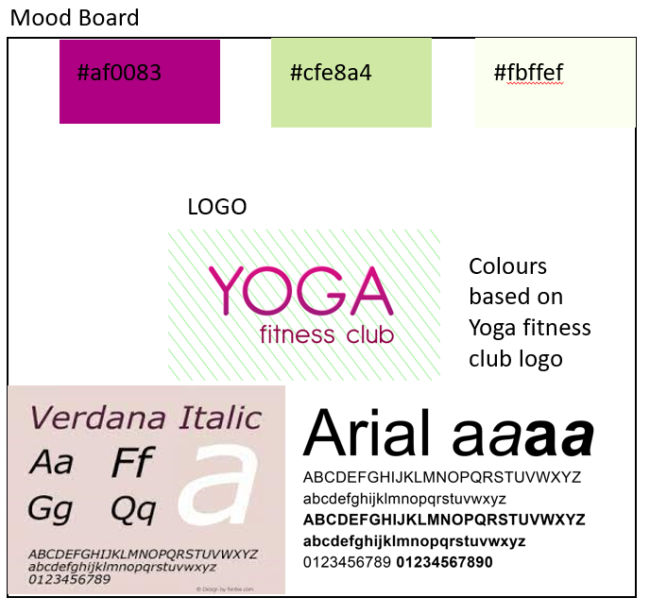

# Story Board 5 pages

There are 4 navigation bar button which are accessible web pages. This is just above the website’s logo.

**Home page**

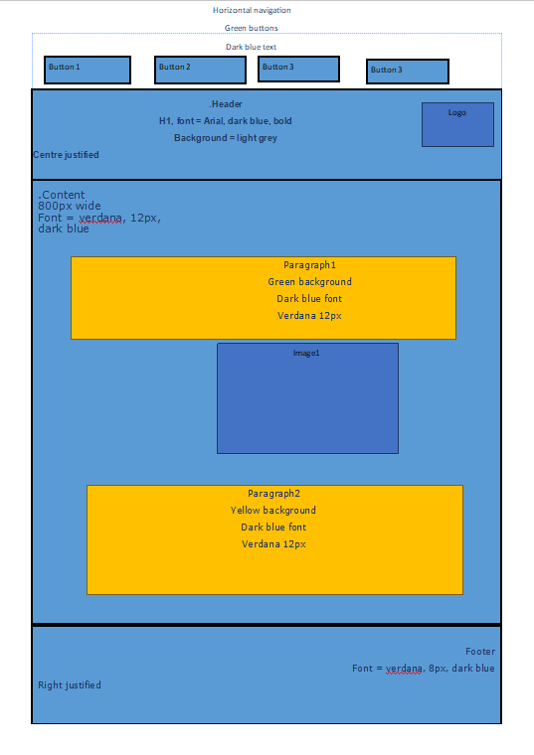

Some information will be provided to explain the purpose of the website.

Image of a yoga position.

A header using the h1 element by opening and closing the HTML tag.

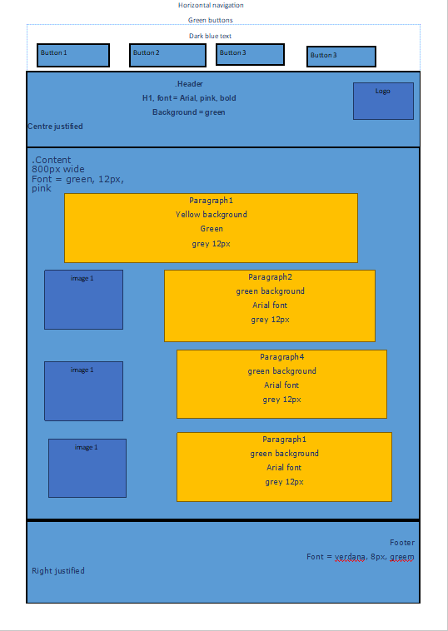**Services page**

Each image has its own description of the yoga position revealed.

Yoga images

There are 4 navigation bar button which are accessible web pages. This is just above the website’s logo.

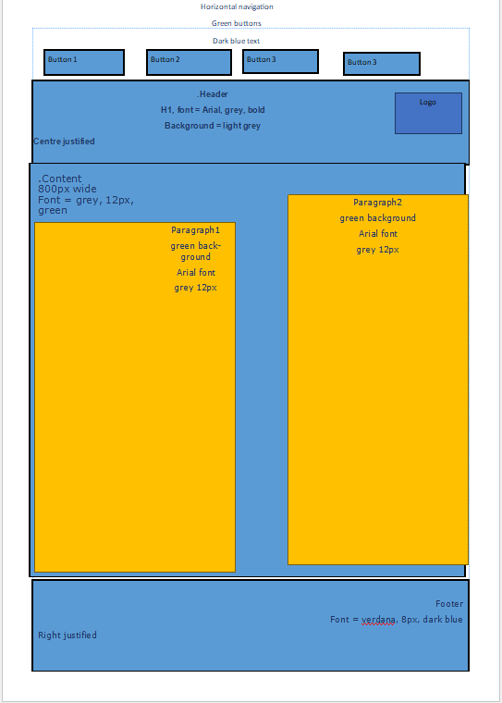**Classes page**

These two paragraphs will contain dates and times for each yoga class for both male and female.

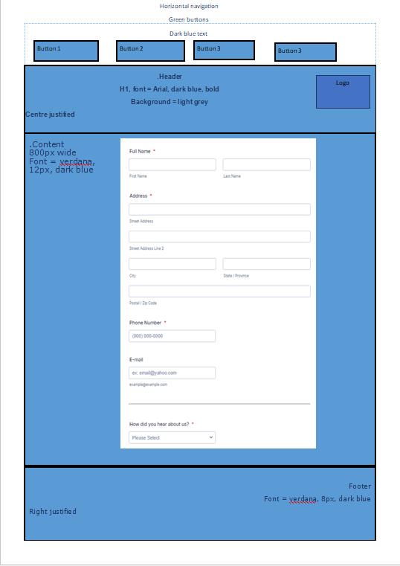**Membership page**

This is a form page which will allow a membership sign up to take place and this will validate if it meets the requirement or not.

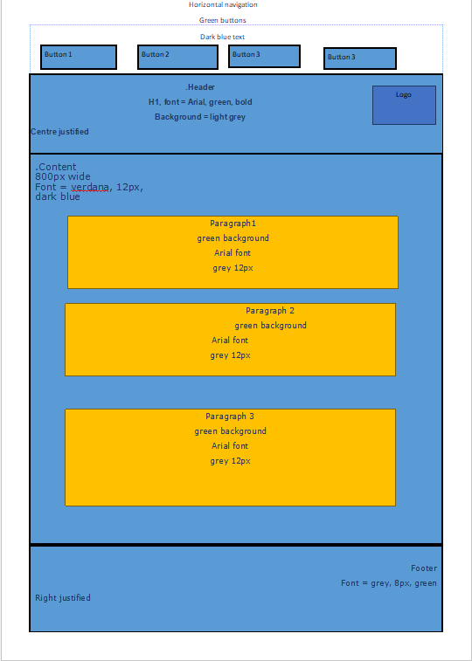**About us page**

This is a “about us” page which will give an in depth explanation about the yoga fitness club

# Navigation Structure

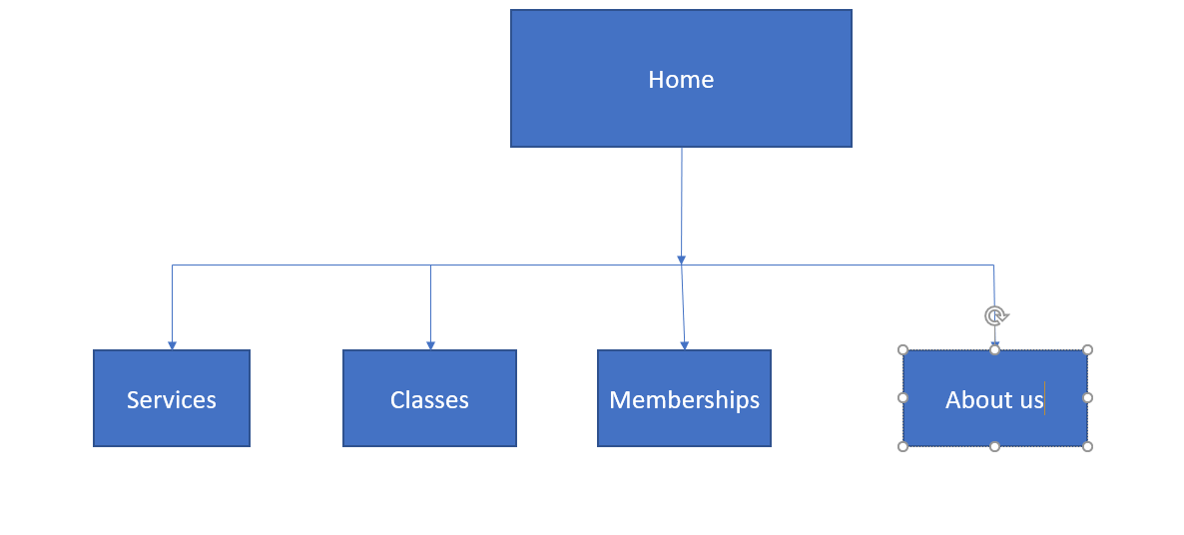

# Story board 5 pages alternative

**Main page**

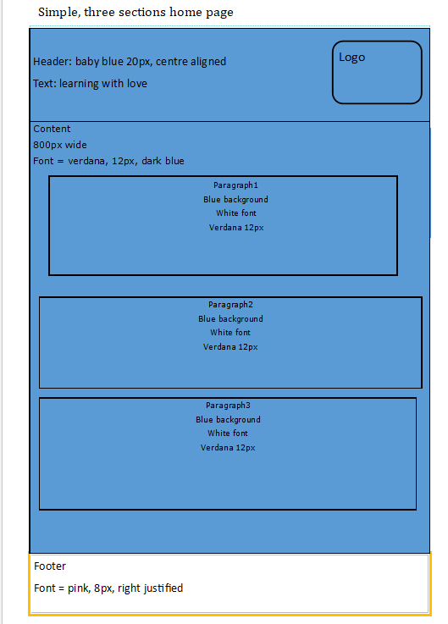

This is a “about us” page which will give an in depth explanation about the yoga fitness club

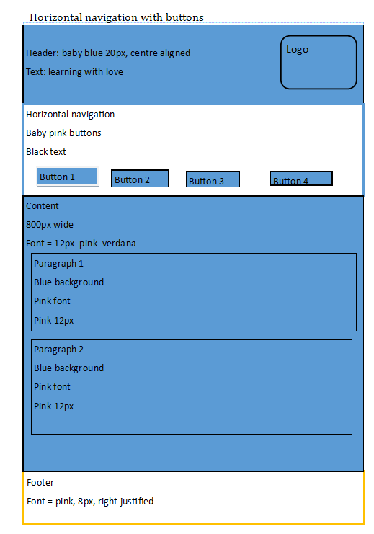**Page 2**

Interactive buttons which will take them too different pages

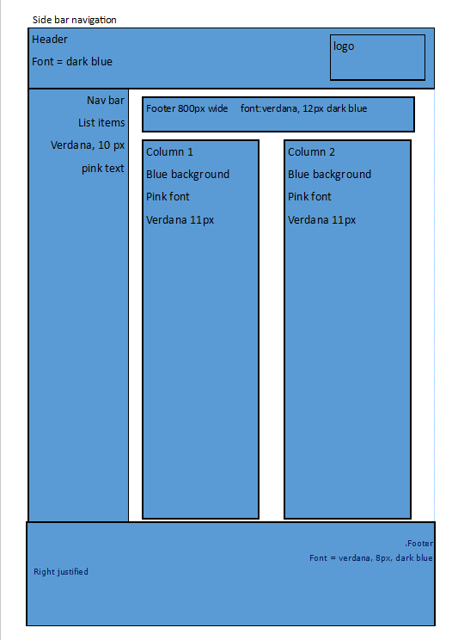**Page 3**

Interactive navigation bar which will also have two columns popping out.

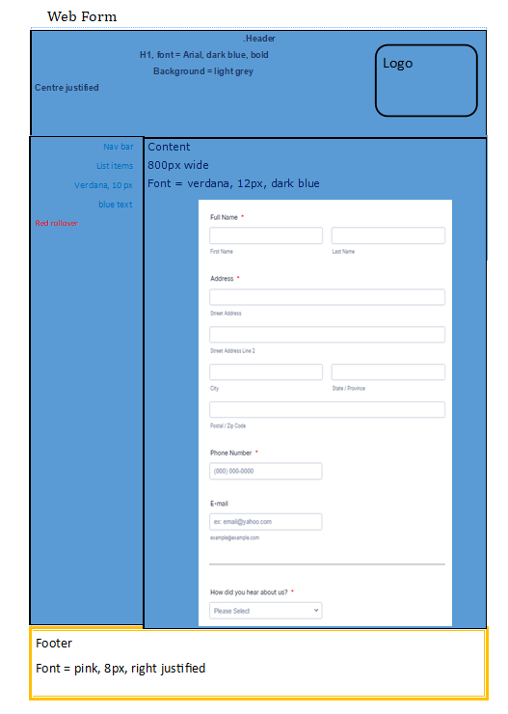**Page 4**

A form page

# Feedback from client

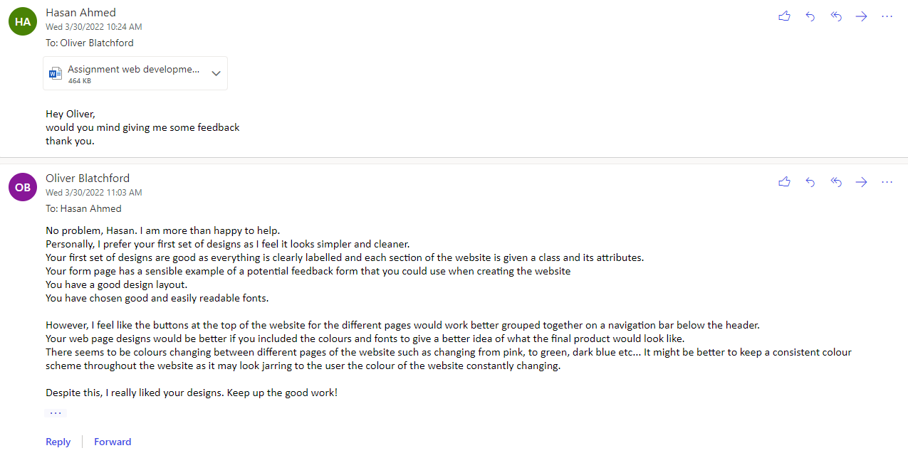

|  |  |  |  |  |  |
| --- | --- | --- | --- | --- | --- |
|  | 5 | 4 | 3 | 2 | 1 |
| Readability |  |  | x |  |  |
| Font choices |  |  |  | x |  |
| Colour scheme | x |  |  |  |  |
| Intuitiveness |  |  | x |  |  |

# Feedback from potential user

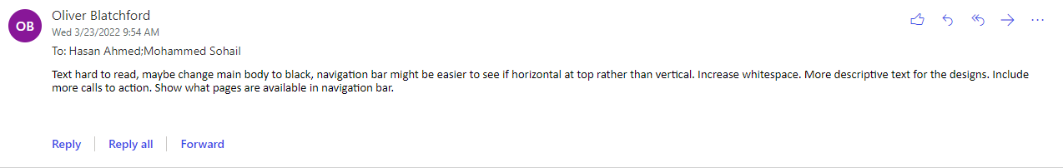

|  |  |  |  |  |  |
| --- | --- | --- | --- | --- | --- |
|  | 5 | 4 | 3 | 2 | 1 |
| Readability |  |  |  | x |  |
| Font choices | x |  |  |  | x |
| Colour scheme |  |  | x |  |  |
| Intuitiveness |  | x |  |  |  |

# Make improvements on visual designs

# Justify the design decisions, explaining how they will meet the user's needs and be fit for purpose

# Implementation of the website

# Testing and optimizing the website

|  |  |  |  |  |
| --- | --- | --- | --- | --- |
| **Test #** | **Description** | **Expected Outcome** | **Actual Outcome** | **Pass / Fail** |
| 1 | Spell check all web pages | No spelling or grammar error | Missing ‘on home page  Missing capital letter on contact page | Fail |
| 2 | Logo should appear on all pages | Logo is displayed 200px x 200px | Logo is displayed as expected | Pass |
| 3 | Check all links on all pages | Correct page should load | Link on training course page does not link to home page | Fail |
| 4 | Check name is mandatory field | Alert box displayed if name not entered | Alert box was displayed | Pass |
| 5 | Validate email address | Error message if no @ sign | Error message not displayed | Fail |
| 6 | Test on Chrome and Safari | Page renders as expected | Page renders as expected | Pass |

**Optimization**

Test number 1: Added missing quote mark ‘on home page. Added capital letter on contact page for name of company.

Test number 3: Added <a> tag with link back to index.html

Text number 5: Changed html form element to type email which automatically validates email address.

# Evaluation of the design and optimised website against client requirements.

# Overall reflection on the project

# References

Brij Mishra. (2022). *Market Analysis on the Yoga Industry Table of Contents.* Available: https://www.academia.edu/6935790/Market_Analysis_on_the_Yoga_Industry_Table_of_Contents. Last accessed Thursday 24th March 2022.